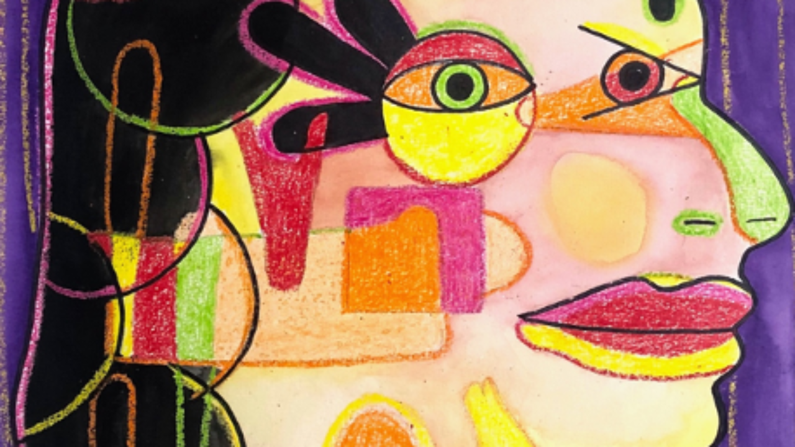

**Starlings - Autumn Term 1 2022**

**It’s Good to be Me**

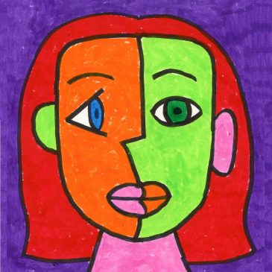 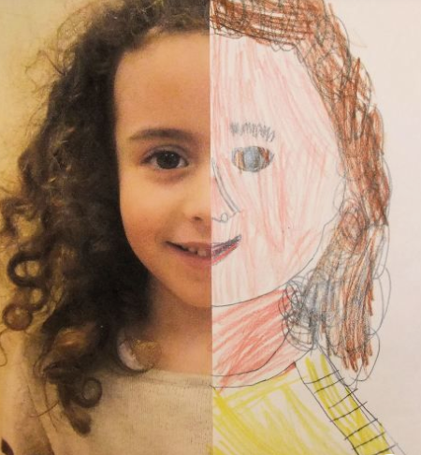

**Physical Development**

PE with Mr. Pearce

Team Building Games

Ball Skills

Tennis

Dance

Health and Wellbeing

Fine Motor Skills

Forest School

**Personal Social Development**

Class Rules

TEAM=Together Everyone Achieves More

Taking Turns and Listening to Each Other

Being Kind

Bullying and Teasing

Making Good Choices

**RE**

What is God like?

The Parable of The Lost Son

Love and Forgiveness

Prayers

**History / Geography**

Mapping

Atlas Skills

Finding the Continents and Oceans

**Visit:**

A surprise visit from an ex-dental nurse to teach us about the importance of good oral health**.**

**Knowledge and Understanding of the World (Science) Continuous/Enhanced Provision**

Labelling different parts of the body STEM Activities, X-rays, Mirrors

Learning About the 5 Senses Sensory Games

Exploring Different Flavours, Smells, Textures and Sounds Herb Pots, Feely Bag, Optical Illusions

Basic Needs and Healthy Diet Doctor / Dentist Role Play

Using Scientific Vocabulary Word Banks, Science Display

**Creative Development**

**Art/DT**

Pablo Picasso and Self-Portraits

Proportions and Shapes of Facial Features

Using Charcoal, Paints and Pastels

Colour Mixing

**Music**

Heads, shoulders, knees and toes

Musical composition and algorithms

Percussion

**Problem Solving, Reasoning and Numeracy** **Continuous/Enhanced Provision**

Number and Place Value Dice Games, Card Games

Addition and Subtraction Number Games, Numicon

2D and 3D Shapes Creating 2D Images from Shapes

Money / Snack Bar Real Money for Snack

Daily Time Table Visual Timetable with Clocks

Technology – Using a Mouse and a Keyboard Chromebooks

**Communication, Language and Literacy Continuous/Enhanced Provision**

Class Rules – Making Mistakes and Making It Better PSHE Games

Friendships – ‘Little Hedgehogs Big Day’, ‘Side by Side’ Teambuilding Stories and Games

Labels and Captions – Funny Bones Cotton Buds and Card

Naming Body Parts Doctor’s Surgery Role Play

Information Texts About Human Body and Senses Herb Pots, Natural Resources

Descriptive Writing Word Mats

Poetry About Senses Rhyming Games