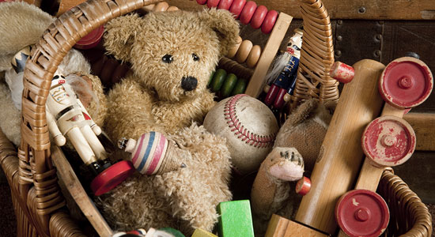

**Starlings - Autumn Term 2 2022**

**Toys and Games**

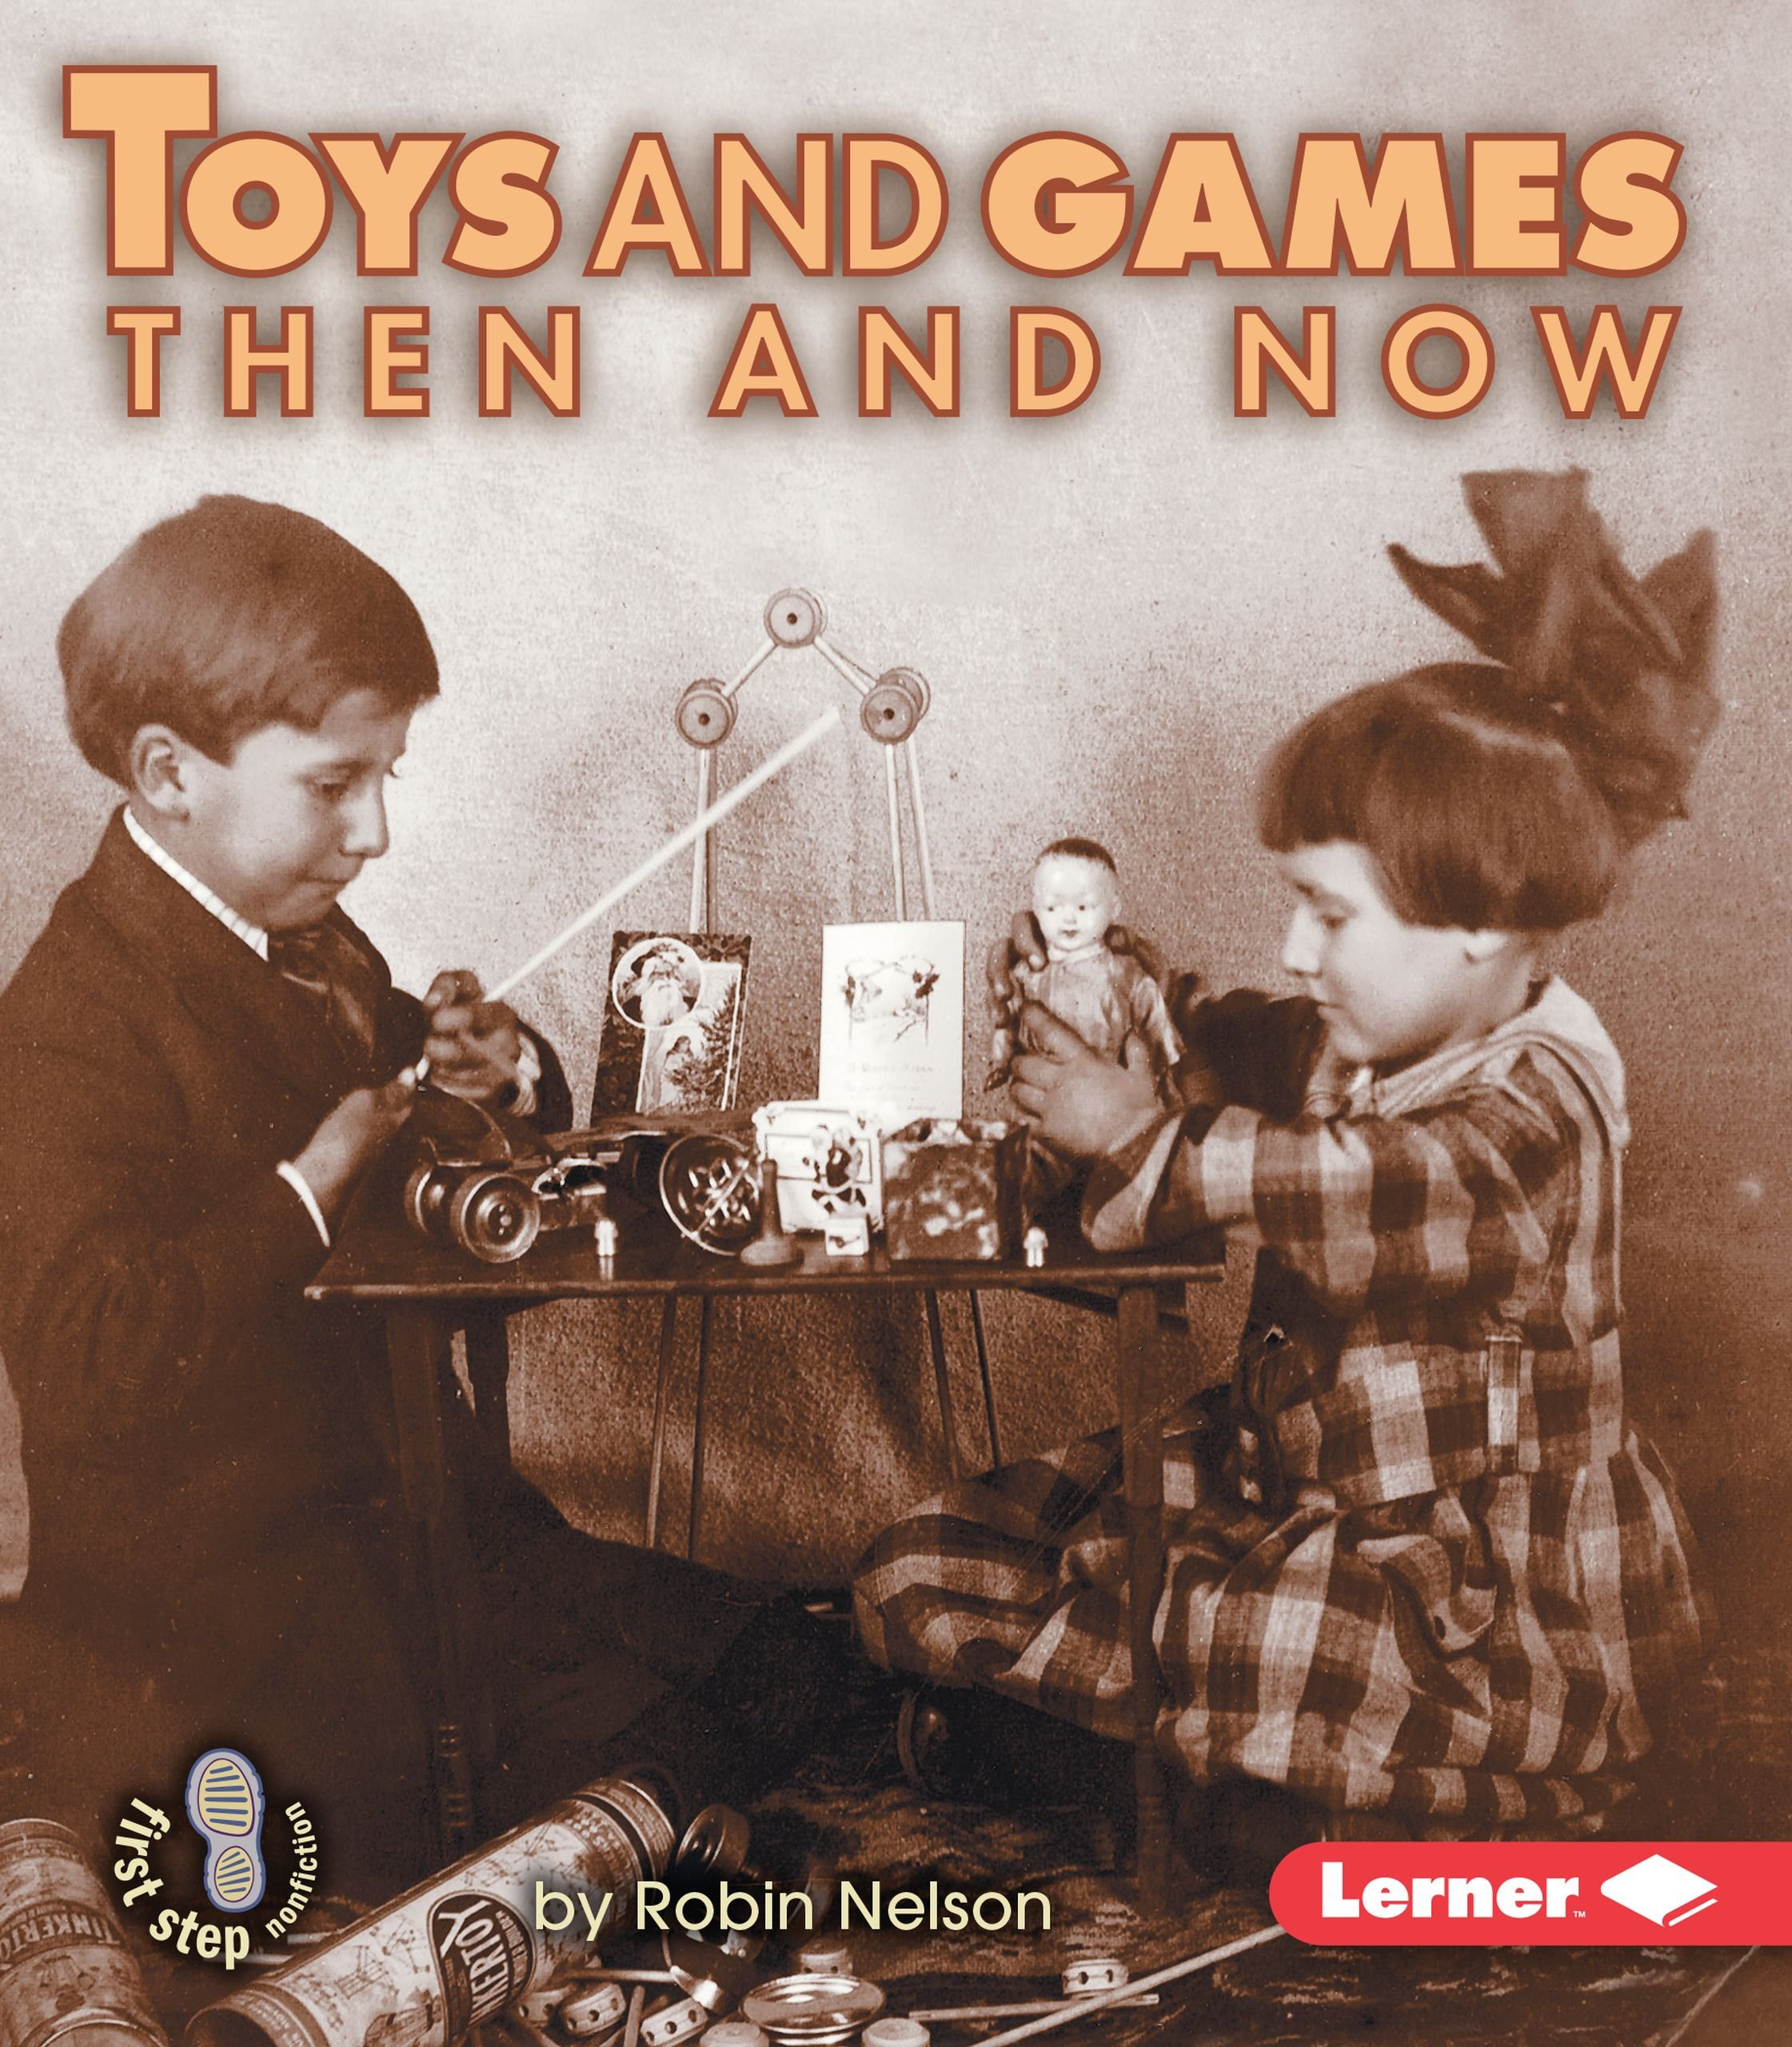 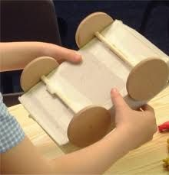

**Physical Development**

PE with Mr Pearce

Attack and Defence

Basketball

Netball

Dance

Fine Motor Skills

Health and Wellbeing

Forest School

**Personal, Social, Health and Economic education**

Important People in Our Lives

Families

Friends and Falling Out

Working Together

Showing Care and Respect

**RE**

Understanding Christianity

Forgiveness

Generosity

The Christmas story – incarnation

**Knowledge and Understanding of the World (Science) Continuous/Enhanced Provision**

Materials Around Us Variety of Materials to Explore

Objects and Materials Investigations of a Variety of Objects

Properties of Materials Testing Properties

Umbrella Investigation Practical Experiments

Sorting of Materials Old and New Materials and Toys

**Communication, Language and Literacy Continuous/Enhanced Provision**

Labels and Captions Toy Shop Role Play

Letter Writing Letter Paper and Supplies

Fiction Involving Fantasy- The Magic Bed Story Sacks, Small World Play

Character Descriptions Stories With a Toy Theme

Story Planning Story Mountain Display

Non-fiction Texts – Toys Through Time Fiction / Non-fiction Text

Christmas Activities Toy Story Movie

**Problem Solving, Reasoning and Numeracy** **Continuous/Enhanced Provision**

Number and Place Value Number Games, Dice and Card Games

Addition and Subtraction Loose Parts, Manipulatives

2D and 3D shapes Creating Images from 2D Shapes

Properties of Shapes 3D Shapes Nets for Construction

Position (linked with music) Beebots, Positional Language

Money Toy Shop

**History / Geography**

Toys Old and New

Making a Traditional Wooden Spoon Toy

Materials and Features of the Past

**Creative Development**

**Art/DT:**

Joining Techniques

Moving Toys

Remembrance Art

Christmas Crafts

**Music**

Vivaldi – The Four Seasons

Understanding how music can represent a physical object or a feeling

**Visit:**

Petersfield Museum – Toys Through Time