**Understanding Physical Development, Health and Wellbeing**

PSHE:

Rights and responsibilities, class charter, fair trade and fairness, managing my feelings, social skills, making the right choices and working together

**Understanding English, Communication and Languages**

13th September: Celebrating ‘Roald Dahl Day’ and exploring other novels through comparison. Watching film clips and comparing to text: Film reviews.

**Fiction:** Key texts: *‘Charlie and The Chocolate Factory’ by Roald Dahl’*. Structure and features of adventure stories. Character analysis, setting descriptions, dilemmas and endings. Newspaper reports, diary entries and planning a new adventure story.

Folk Tale (Mayan) based on ‘A Chocolate Tree’ by

Linda Lowery’

**Non-Fiction:** Writing a biography. Looking at and analysing Roald Dahl’s biography and writing one for Michael Morpurgo.

**Spelling, Punctuation and Grammar:** Basic sentence structure recap, different sentence length,conjunctions, adjectives, time conjunctions, punctuating direct speech, pronouns and verbs, writing in the past tense, prefixes, suffixes.

**Mathematical Understanding**

Number and place value knowledge

Addition and subtraction (mental and written methods)

Multiplication and division (mental and written methods)

Times tables (regular practice to aid fluency)

Measurement – weights, money, time

Linking themes to the text:

Baking, measuring ingredients, adding up tuck shop sweet prices and investigating weights of different packaging.

*‘Charlie and the Chocolate Factory’*

Kingfishers- Autumn Term

v

**Computing**

Internet safety

Topic related videos

Exploring Google Earth

Retrieving info from websites

Algorithms/ maths problems

Writing instructions and debugging

Self-marking/ editing

**Historical, Geographical and Social Understanding**

History:

Family trees/ different family relationships

Aztec & Mayans chocolate

History of cocoa- first grown

How did chocolate become so popular?

Cadbury Brothers

Geography:

Make a map of the chocolate factory showing the different rooms described in the book.

The journey of cocoa- from bean to bar!

Who grows cocoa?

Fairtrade and its importance

Investigating the right conditions and countries where cocoa is grown- why are they suitable?

Using globes and maps

Cost and manufacturing

**French:** West Sussex syllabus

Chocolate foods, greetings, asking to buy chocolate and other foods,

Listening to and reading French traditional tales, instructions.

[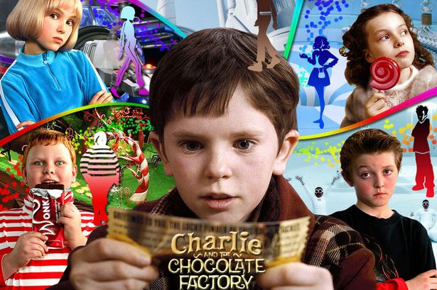](https://www.google.co.uk/url?sa=i&rct=j&q=&esrc=s&source=images&cd=&cad=rja&uact=8&ved=2ahUKEwjh8fOv-NDcAhVMQhoKHXW8AYsQjRx6BAgBEAU&url=https%3A%2F%2Fwww.mirror.co.uk%2F3am%2Fcelebrity-news%2Fcast-charlie-chocolate-factory-10-6774652&psig=AOvVaw1AORB_-K2v1rG0I8qdAW-2&ust=1533387617089951)

**Scientific and Technological Understanding**

From bean to bar- how is chocolate ‘grown’?

Structure and functions of plants

What do plants need

Seed cycle

Pollination

How can plants help us?

Carrying out our own experiments and observing changes.

Changes of state linked to Chocolate.

**Religious Education**

The Life of the Buddha-

Key Question: Is it possible for everyone to be happy? (Discovery R.E)

Incarnation-

Key Question: What is The Trinity? (UC)

**Understanding the Arts**

Drawing pictures to form understanding of the text ‘CAFC’ e.g. Charlies facial expressions at different points and own interpretations of the chocolate factory’s appearance

Designing and building a room from Willy Wonka’s factory, with moving parts.

Designing their ice cream sundae

Water coloured line drawings inspired by Quentin Blake